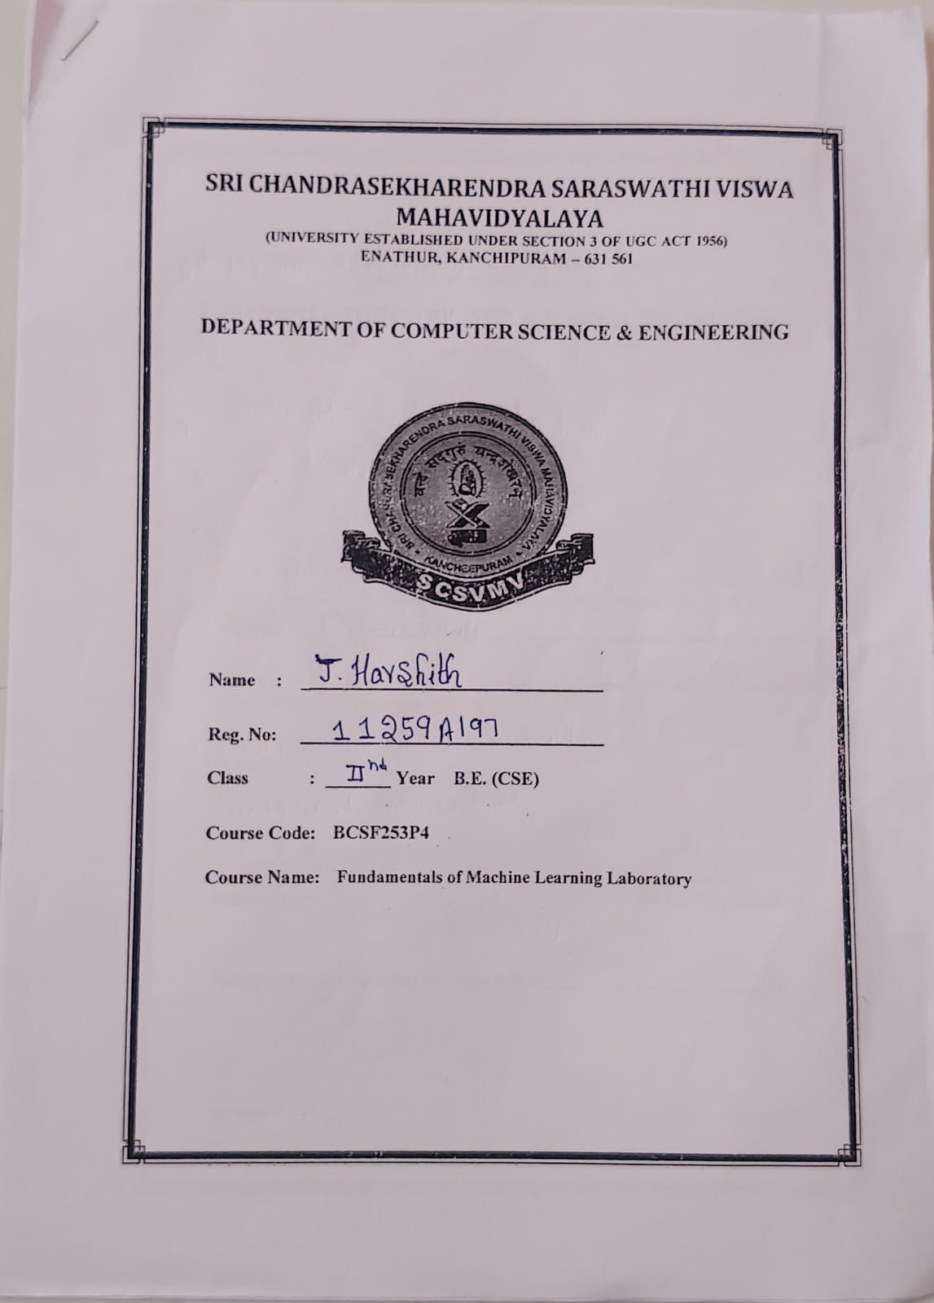

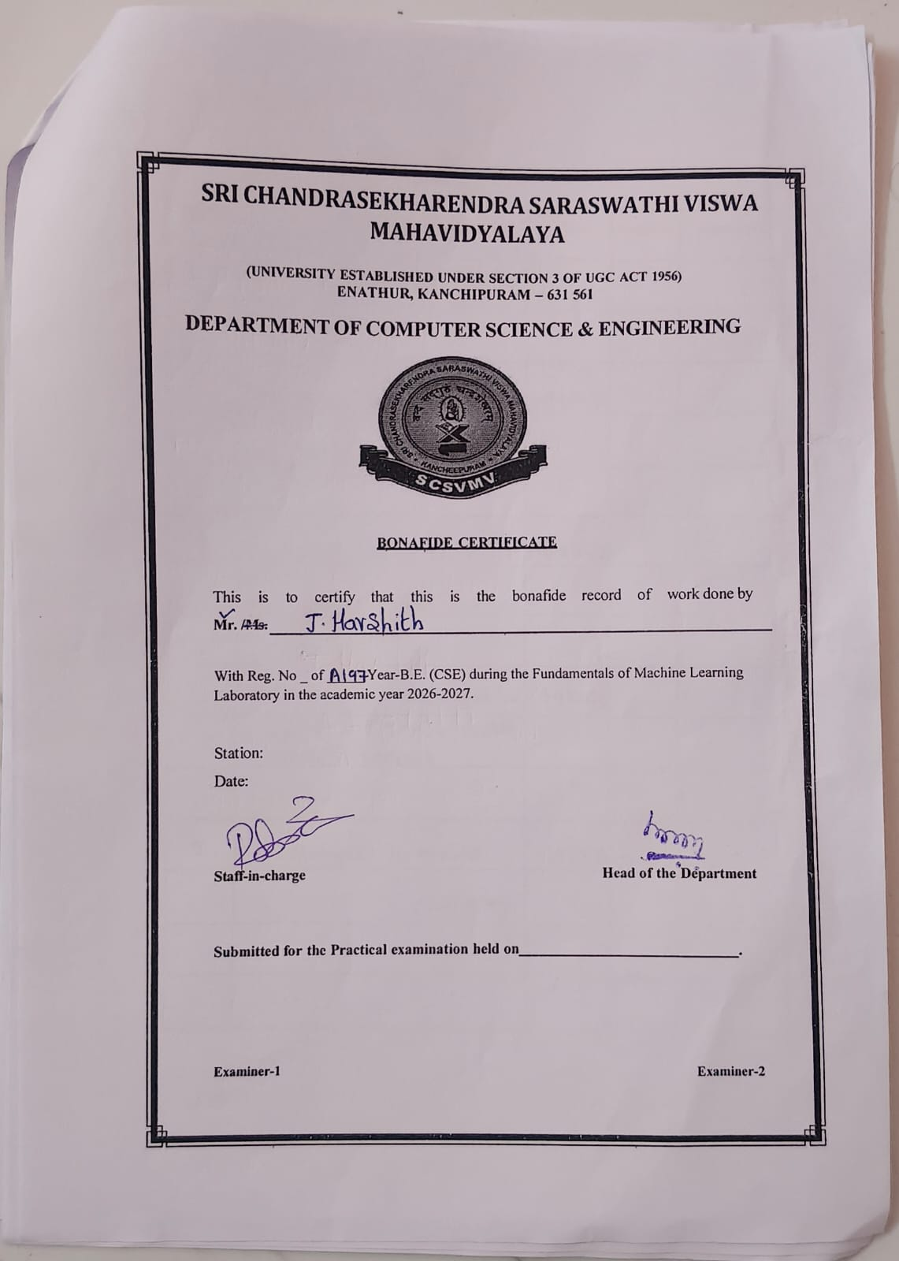
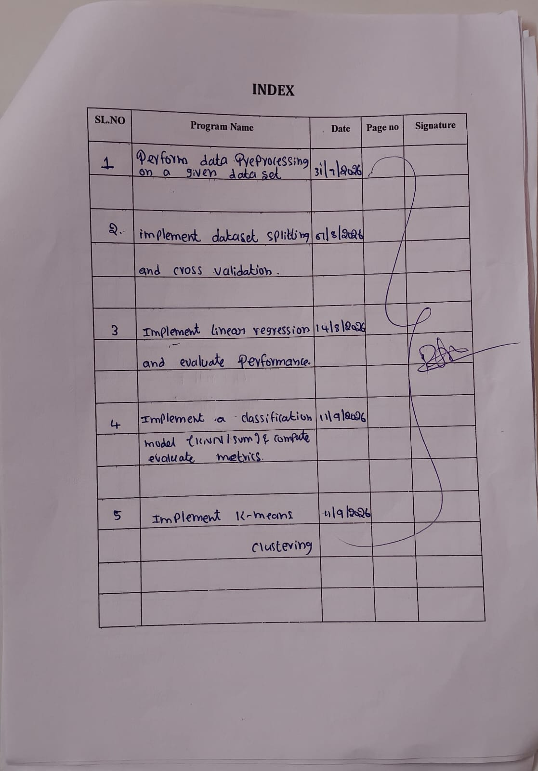
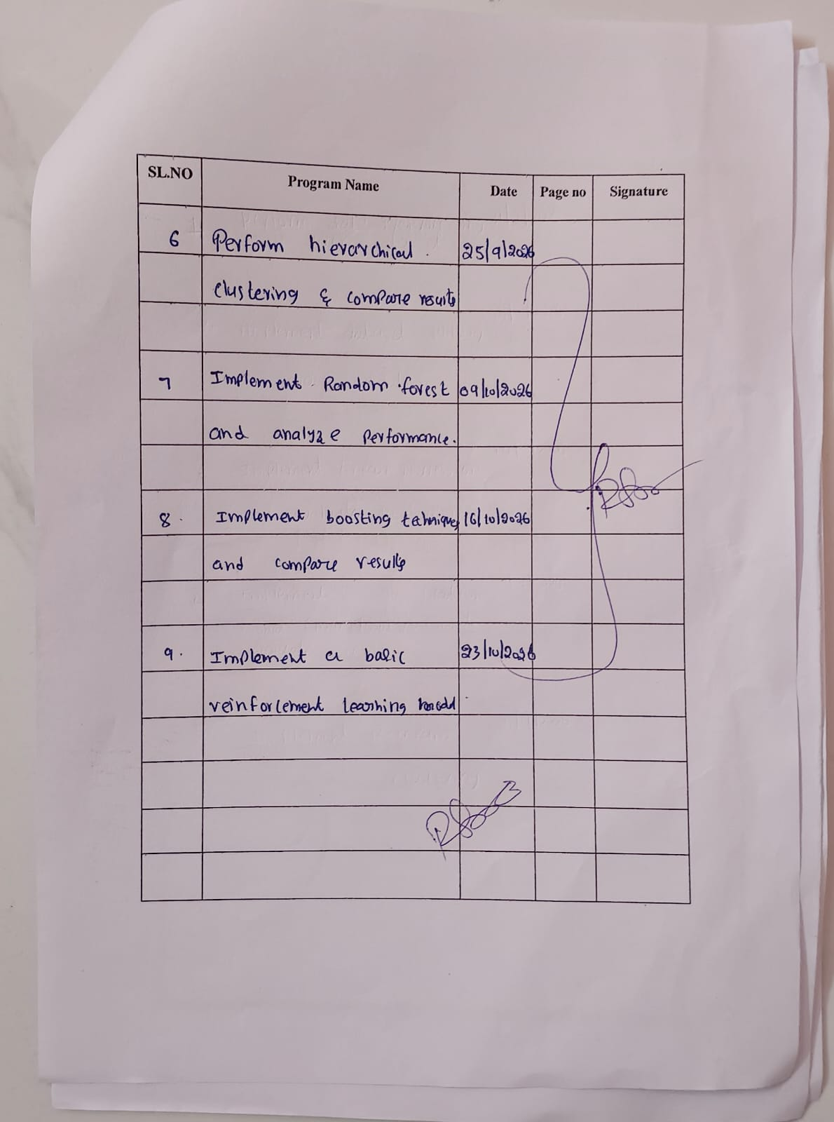

10 EXPERIMENTS

Contents
Experiment 1: Data Preprocessing in a Given Dataset
Experiment 2: Data Splitting and Cross-Validation
Experiment 3: Implement Linear Regression
Experiment 4: Classification Using KNN and SVM with Evaluation Metrics
Experiment 5: K-Means Clustering
Experiment 6: Hierarchical Clustering
Experiment 7: Random Forest Classification and Performance Analysis
Experiment 8: AdaBoost Classification and Performance Analysis
Experiment 9: Basic Reinforcement Learning Using Q-Learning
Experiment 10: Neural Network Classification

Note: The code-editor and console images are recreated PyCharm-style illustrations, not screenshots captured from an installed PyCharm application. Graphs shown in the output section are generated example plots for the corresponding experiment. Sample outputs and metrics can vary with the dataset, random seed, and installed library versions. Save data.csv in the same project folder before running experiments that read it.

EXPERIMENT 1
Data Preprocessing in a Given Dataset
Aim
To load a dataset, inspect missing values, fill missing numerical values, and standardize numerical features.
Algorithm
1. Import pandas and StandardScaler.
2. Read the dataset from data.csv and display its first five rows.
3. Check the number of missing values in each column.
4. Fill missing numerical values with the corresponding column mean.
5. Select Hours_Studied, Attendance, Assignments, and Marks as numerical features.
6. Apply StandardScaler and display the normalized dataset.
Code
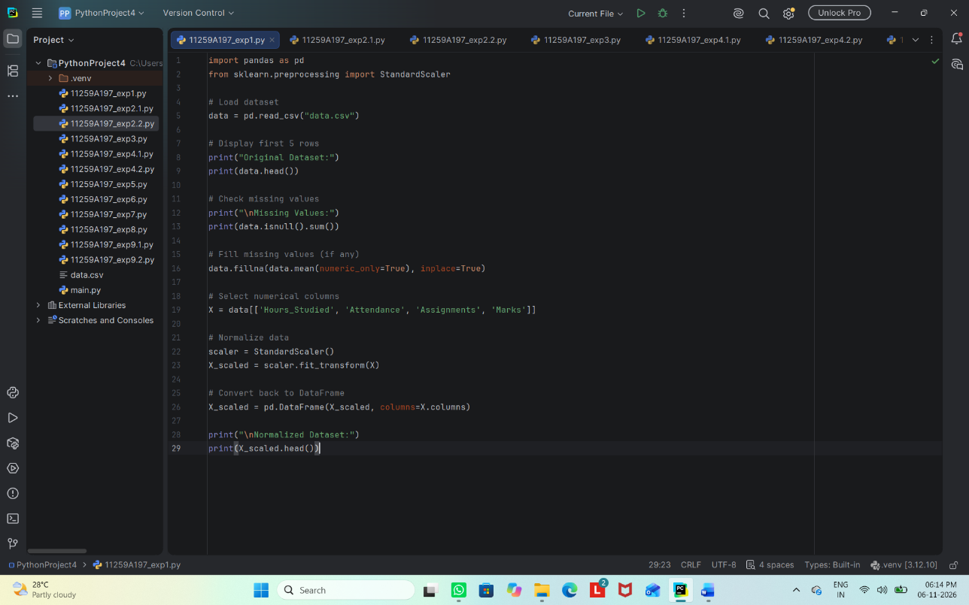

Output

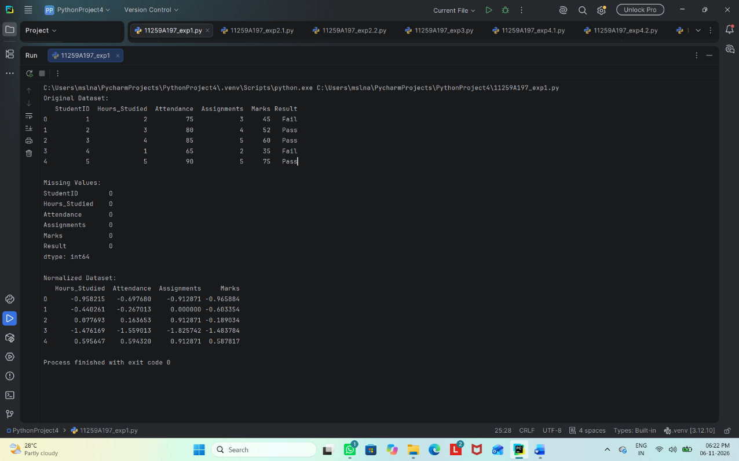

Result
Thus, the dataset was inspected, missing numerical values were handled, and numerical features were standardized successfully.

EXPERIMENT 2
2.1 Data Splitting
Aim
To divide the dataset into training and testing sets and display the number of records in each set.
Algorithm
1. Import pandas and train_test_split from scikit-learn.
2. Load data.csv.
3. Select Hours_Studied, Attendance, and Assignments as input features and Result as the target.
4. Split the data into 80% training data and 20% testing data using a fixed random state.
5. Display the shapes of the training and testing sets.
Code
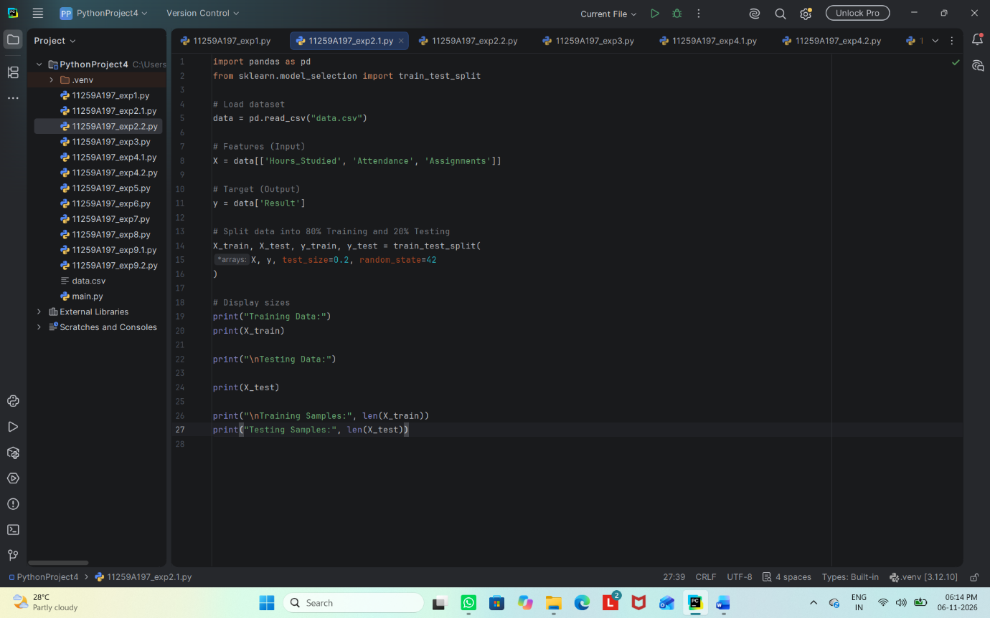

Output
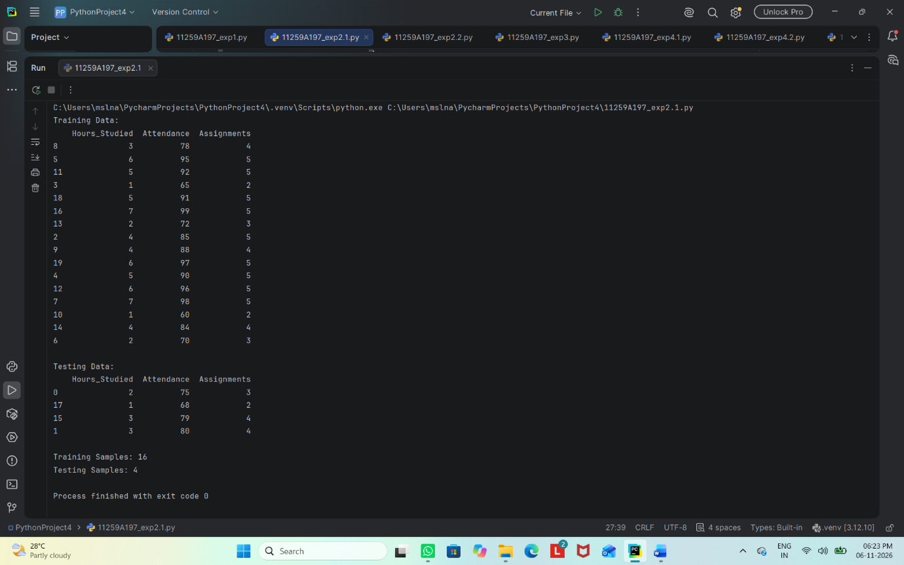

Result
Thus, the dataset was successfully divided into training and testing sets in an 80:20 ratio.

2.2 Cross-Validation
Aim
To evaluate a K-Nearest Neighbors (KNN) classifier using 5-fold cross-validation.
Algorithm
1. Import pandas, KNeighborsClassifier, and cross_val_score.
2. Load data.csv and select the input features and Result target.
3. Create a KNN classifier with k = 3.
4. Evaluate the classifier using 5-fold cross-validation.
5. Display the individual fold scores and their mean accuracy.
Code
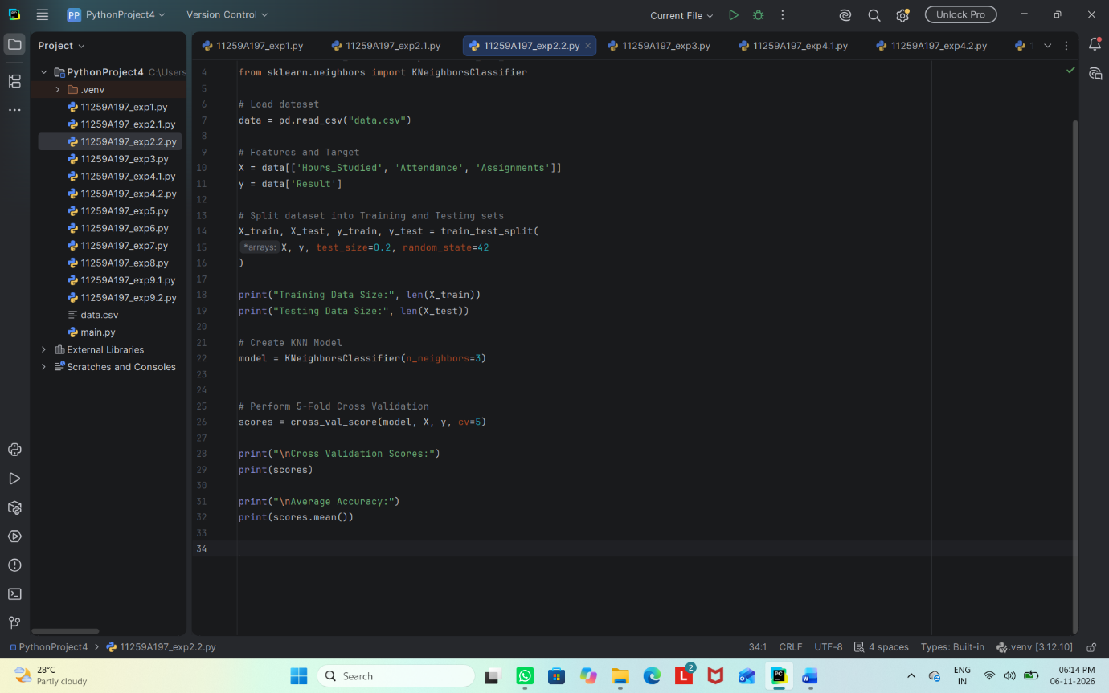

Output

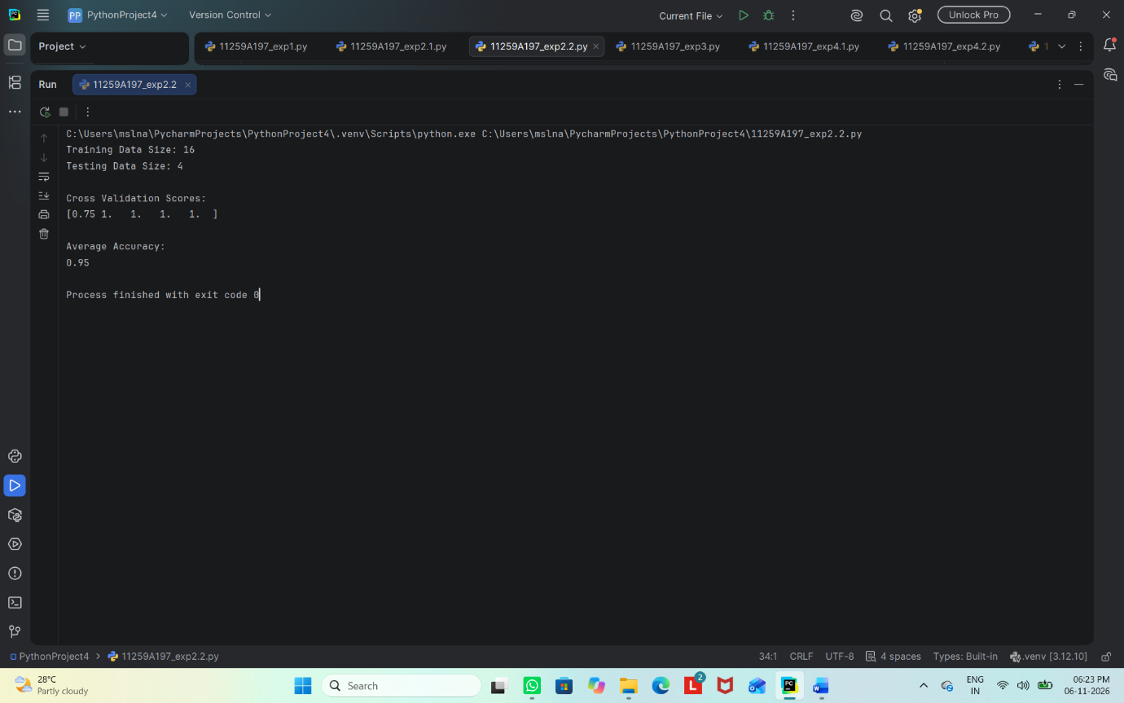

Result
Thus, 5-fold cross-validation was performed and the mean accuracy of the KNN classifier was calculated.

EXPERIMENT 3
Implement Linear Regression
Aim
To build a linear regression model that predicts students' marks from the number of hours studied and evaluates its performance.
Algorithm
1. Import pandas, matplotlib, train_test_split, LinearRegression, and evaluation metrics.
2. Load data.csv and select Hours_Studied as the input feature and Marks as the target.
3. Split the dataset into training and testing sets.
4. Create and train the LinearRegression model.
5. Predict marks for the test set and calculate Mean Squared Error and R² score.
6. Plot the actual test data and regression line.
Code
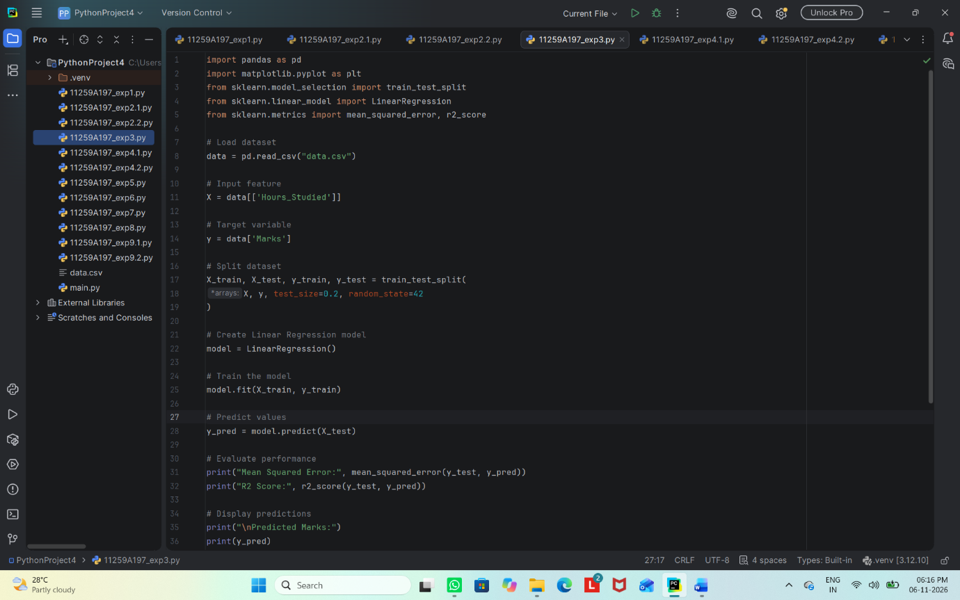
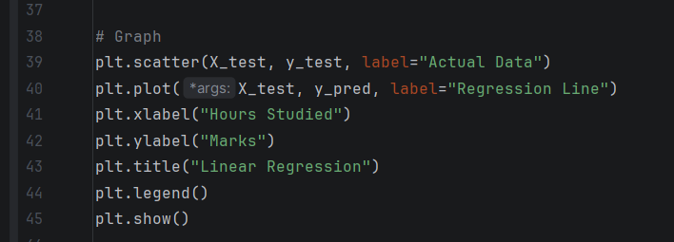

Output
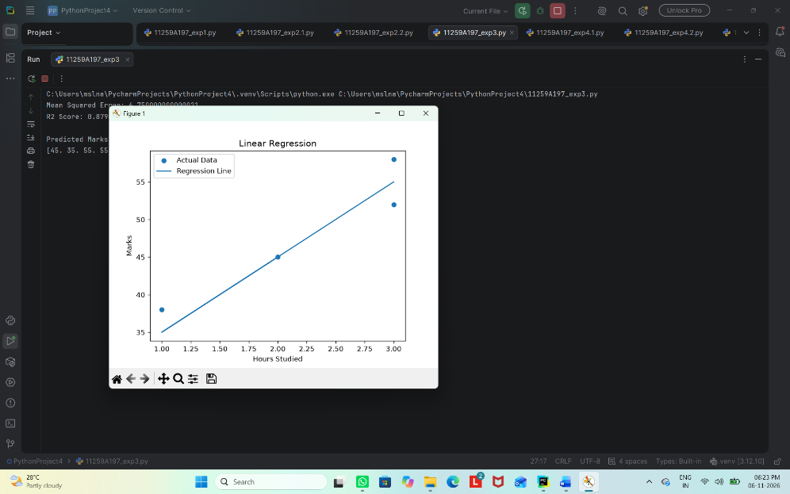

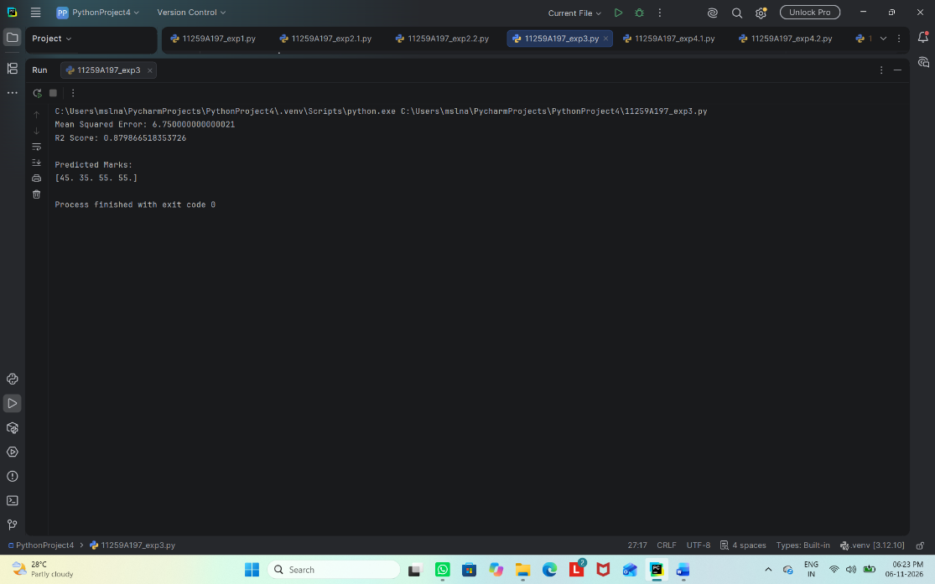
Result
Thus, a linear regression model was trained to predict marks, and its performance was evaluated using MSE and R² score.

EXPERIMENT 4
4.1 KNN Classification
Aim
To train a K-Nearest Neighbors (KNN) classifier and evaluate its predictions using accuracy and a confusion matrix.
Algorithm
1. Import pandas, train_test_split, KNeighborsClassifier, and evaluation metrics.
2. Load data.csv and select Hours_Studied, Attendance, and Assignments as input features.
3. Select Result as the target and split the data into training and testing sets.
4. Train a KNN classifier with three neighbors and predict the test labels.
5. Display accuracy and the confusion matrix.
Code
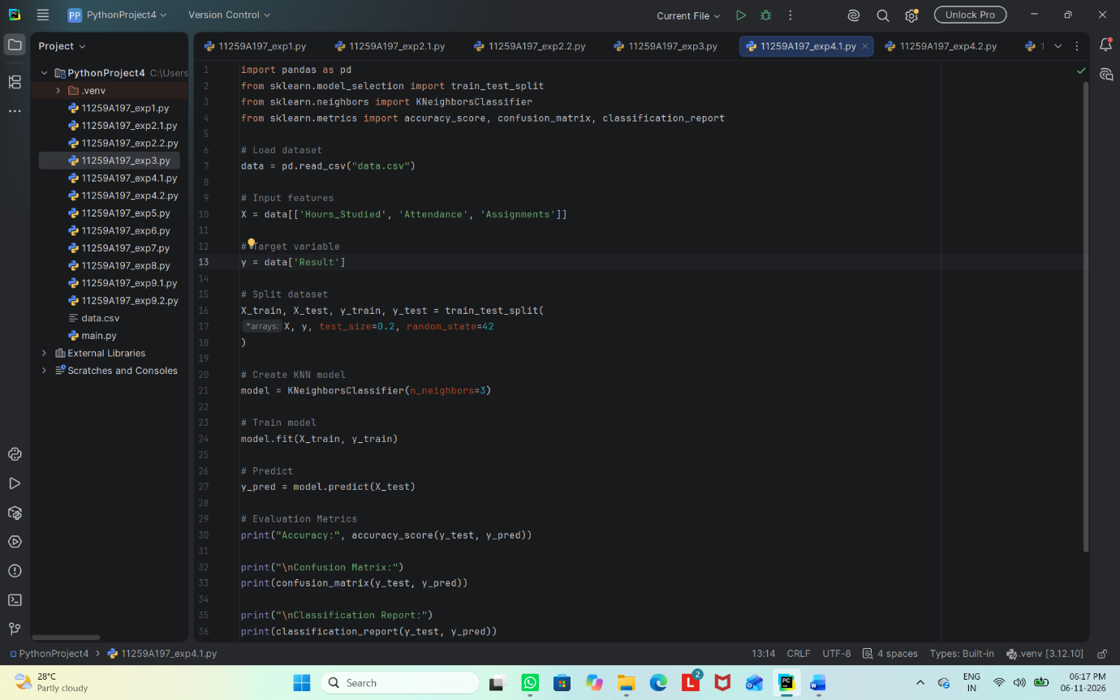

Output
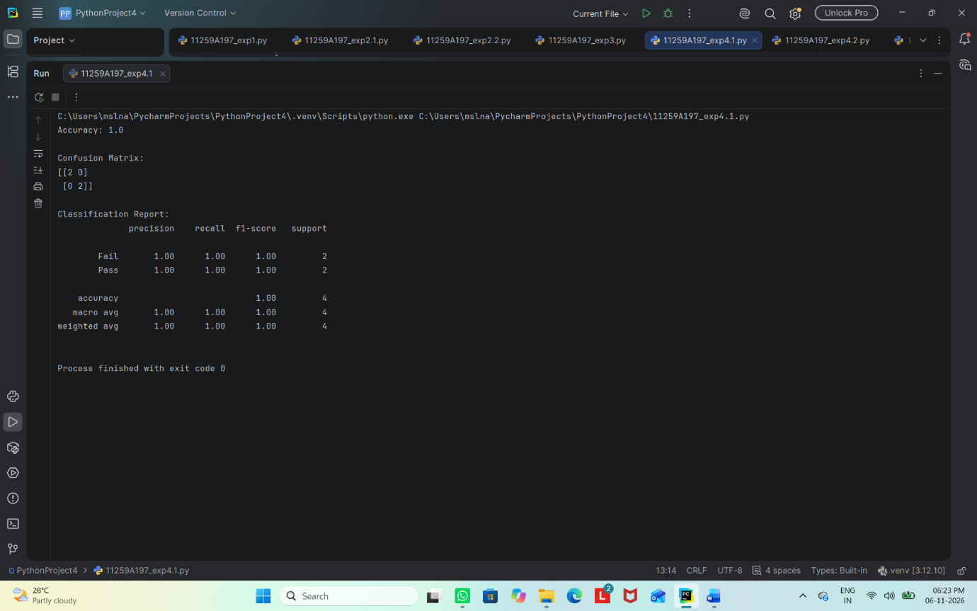

Result
Thus, the KNN classifier was trained and evaluated using accuracy and a confusion matrix.

4.2 SVM Classification
Aim
To train a Support Vector Machine (SVM) classifier and evaluate its predictions using accuracy and a confusion matrix.
Algorithm
1. Import pandas, train_test_split, SVC, and evaluation metrics.
2. Load data.csv and select the input features and Result target.
3. Split the dataset into training and testing sets.
4. Train an SVM classifier with a linear kernel and predict the test labels.
5. Display accuracy and the confusion matrix.

Code
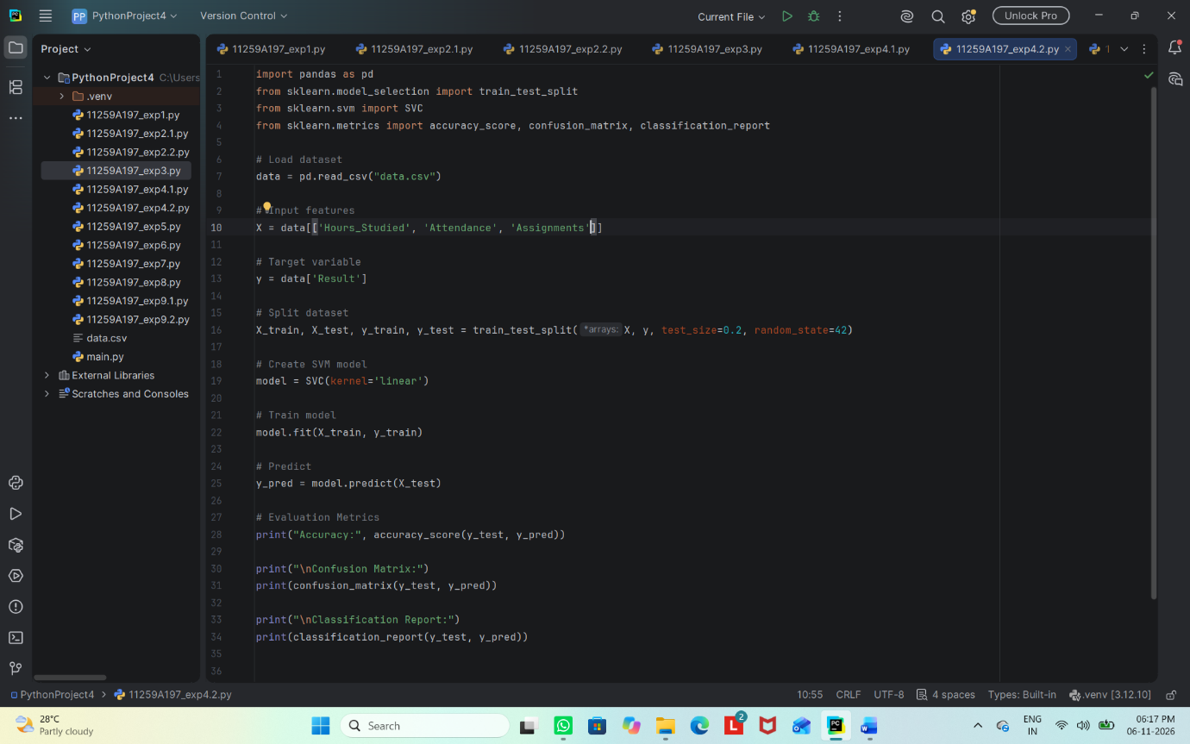

Output
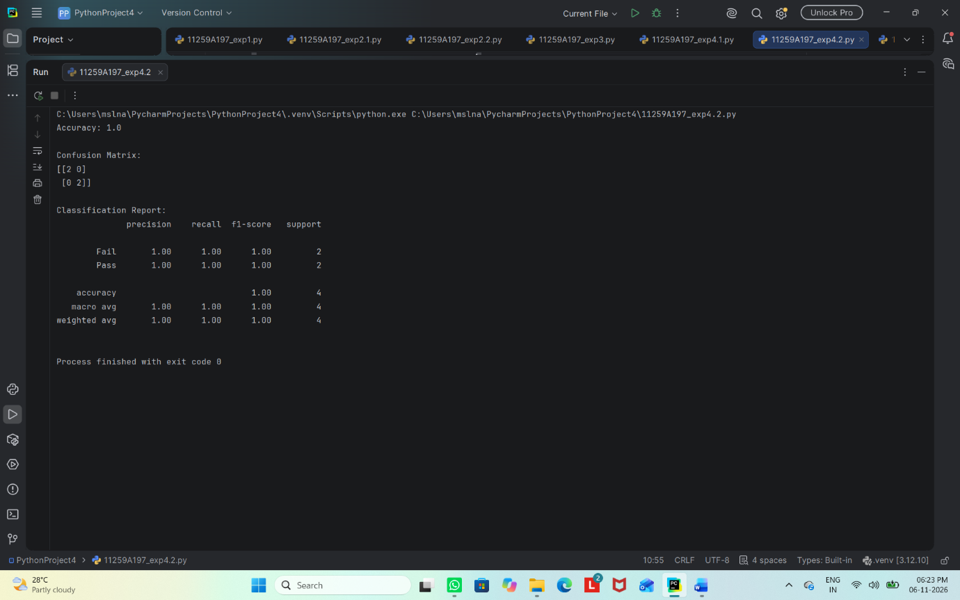

Result
Thus, the SVM classifier was trained and evaluated using accuracy and a confusion matrix.

EXPERIMENT 5
K-Means Clustering
Aim
To group student records into three clusters using K-Means clustering based on study hours and marks.
Algorithm
1. Import pandas, matplotlib, and KMeans.
2. Read data.csv and select Hours_Studied and Marks.
3. Create a K-Means model with three clusters and a fixed random state.
4. Fit the model and obtain cluster labels.
5. Add cluster labels to the dataset and display the result.
6. Plot the data points and cluster centroids.
Code
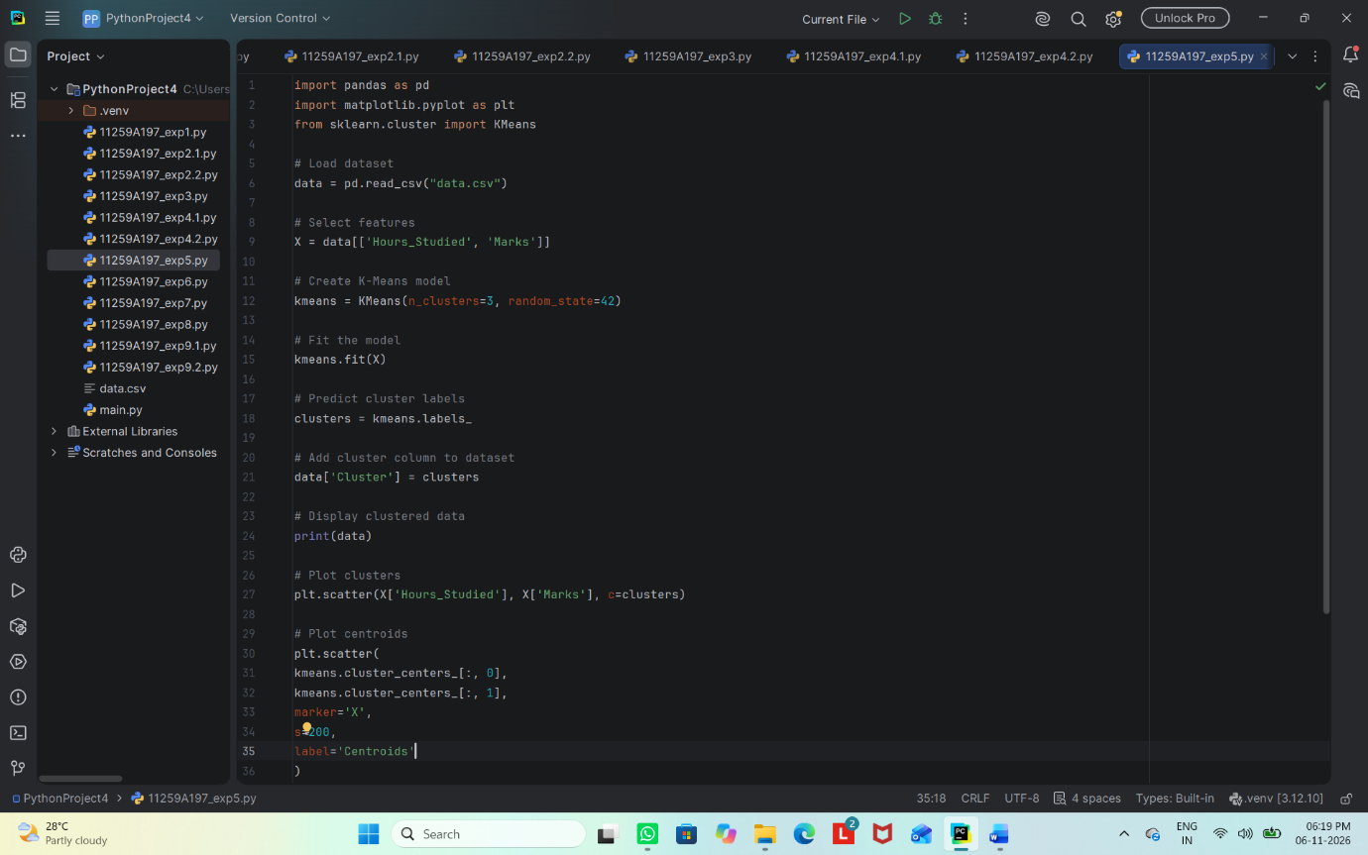
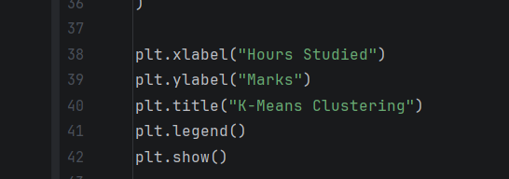

Output
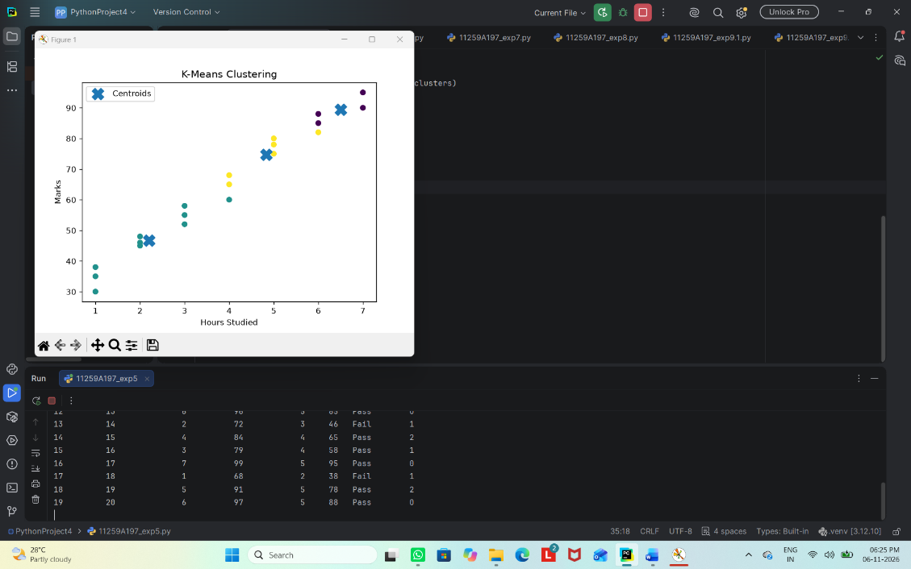

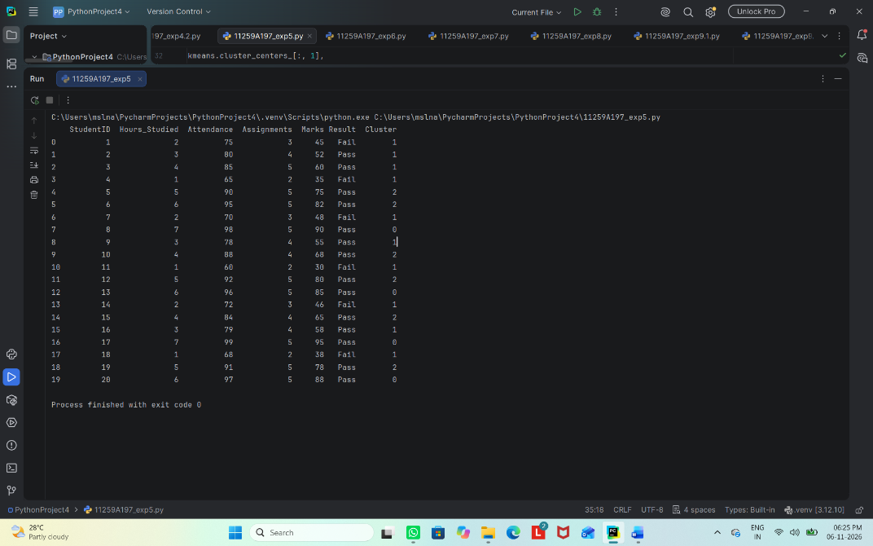

Result
Thus, K-Means clustering was applied to group the student data into three clusters, and the clusters were visualized.

EXPERIMENT 6
Hierarchical Clustering
Aim
To perform agglomerative hierarchical clustering on student data and visualize the results using a dendrogram and scatter plot.
Algorithm
1. Import pandas, matplotlib, linkage, dendrogram, and AgglomerativeClustering.
2. Load data.csv and select Hours_Studied and Marks.
3. Create a Ward-linkage matrix and draw a dendrogram.
4. Apply AgglomerativeClustering with three clusters.
5. Add the cluster labels to the dataset and print the records.
6. Plot the clustered data.
Code
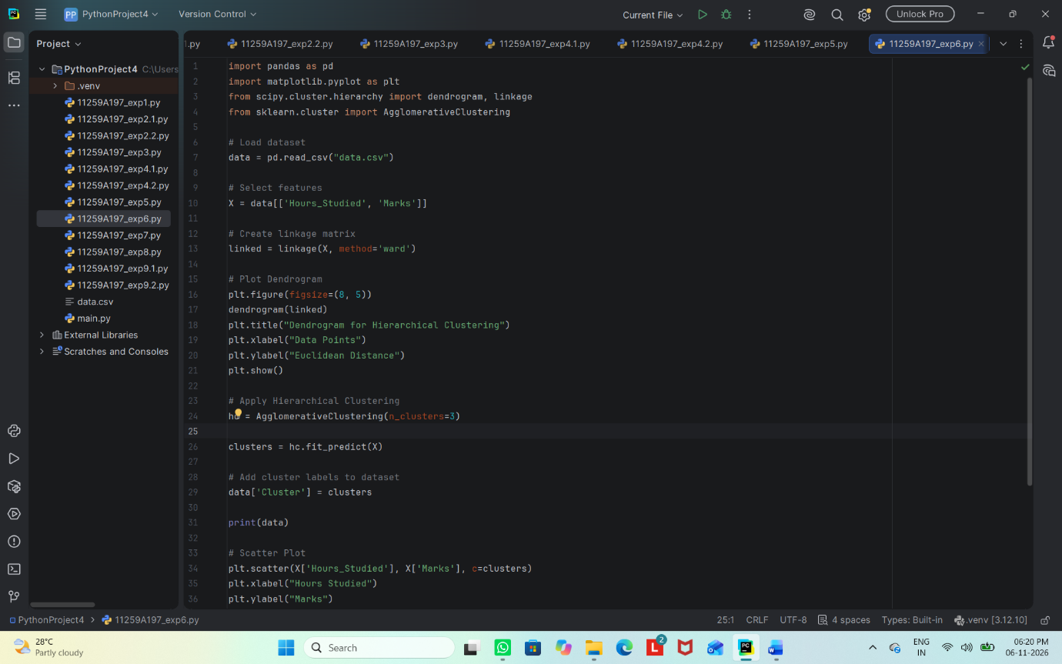

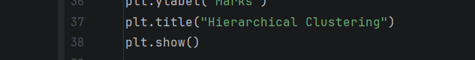

Output
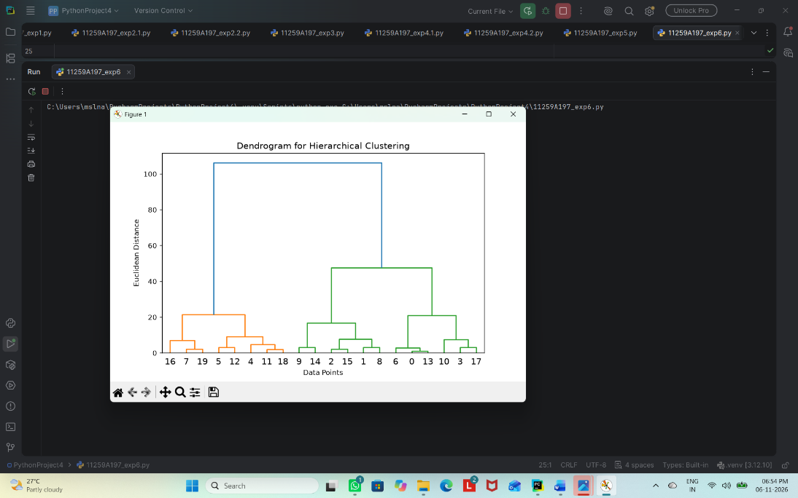

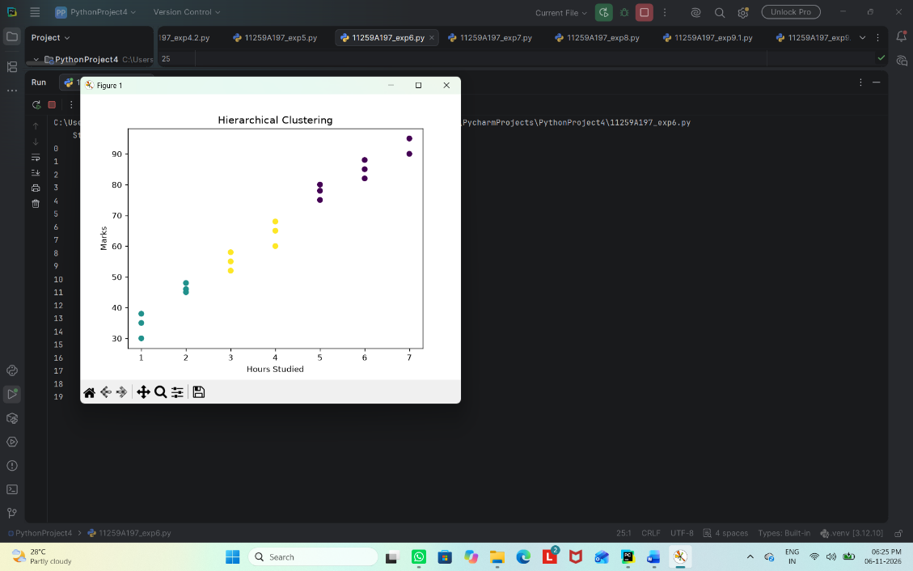

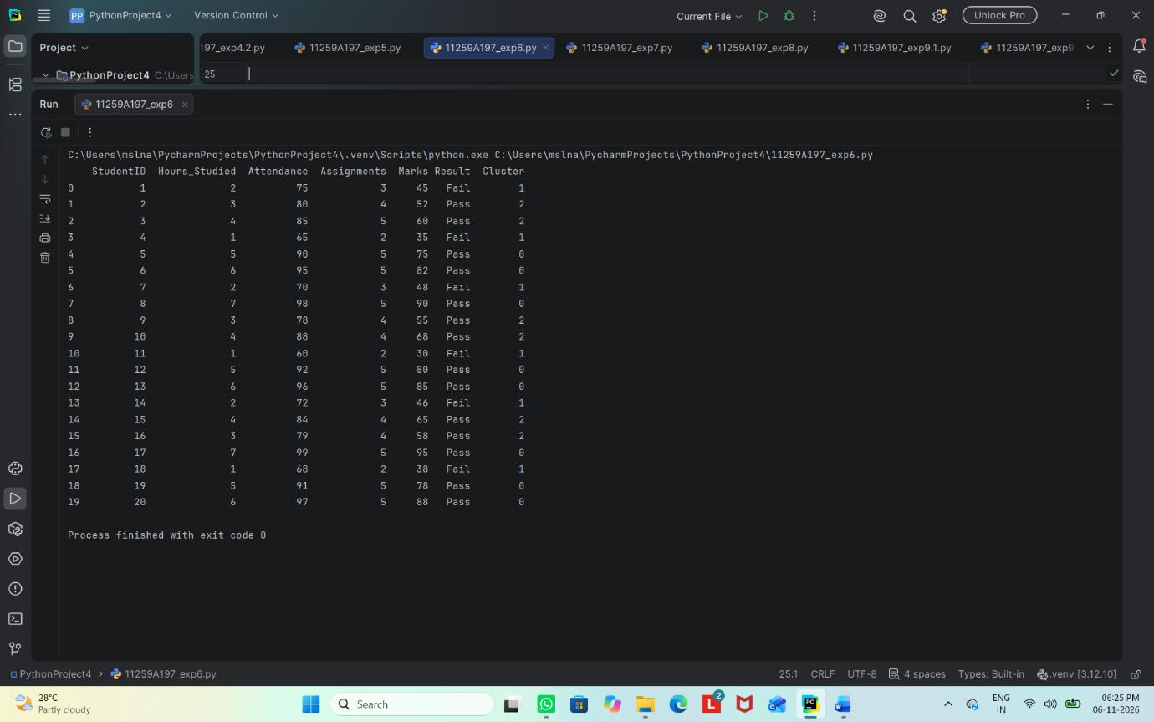

Result
Thus, hierarchical clustering was performed, and the dendrogram and scatter plot were used to visualize the grouping.

EXPERIMENT 7
Random Forest Classification and Performance Analysis
Aim
To classify student results using a Random Forest classifier and analyze its performance and feature importance.
Algorithm
1. Import pandas, train_test_split, RandomForestClassifier, and evaluation metrics.
2. Load the dataset and select Hours_Studied, Attendance, and Assignments.
3. Select Result as the target and split the data into training and testing sets.
4. Train a Random Forest classifier using 100 trees.
5. Predict the test labels and display accuracy, confusion matrix, and classification report.
6. Plot the importance of each input feature.

Code
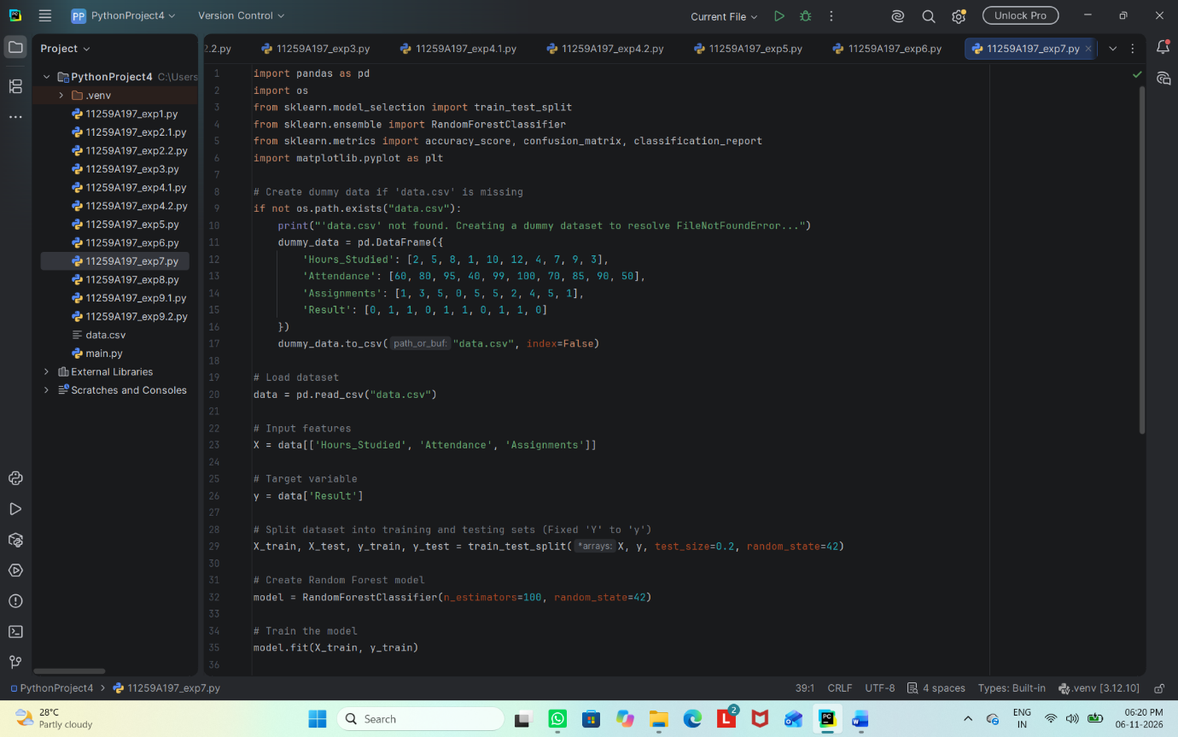

Output

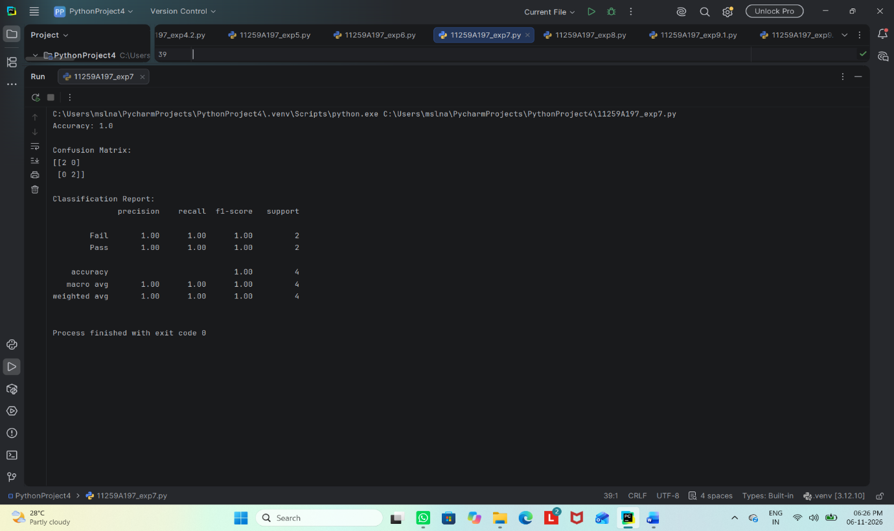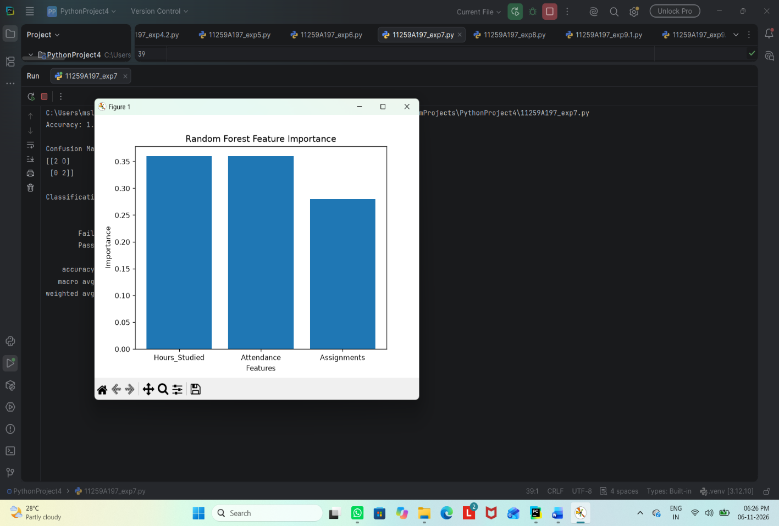

Result
Thus, the Random Forest classifier was trained and evaluated, and the relative importance of input features was visualized.

EXPERIMENT 8
AdaBoost Classification and Performance Analysis
Aim
To implement the AdaBoost ensemble classification technique and evaluate its performance on student result data.
Algorithm
1. Import pandas, matplotlib, train_test_split, AdaBoostClassifier, and evaluation metrics.
2. Load data.csv and select input features and target labels.
3. Split the dataset into training and testing sets.
4. Create an AdaBoost classifier with 50 estimators and a fixed random state.
5. Train the classifier and predict test labels.
6. Display evaluation metrics and plot feature importance

Code
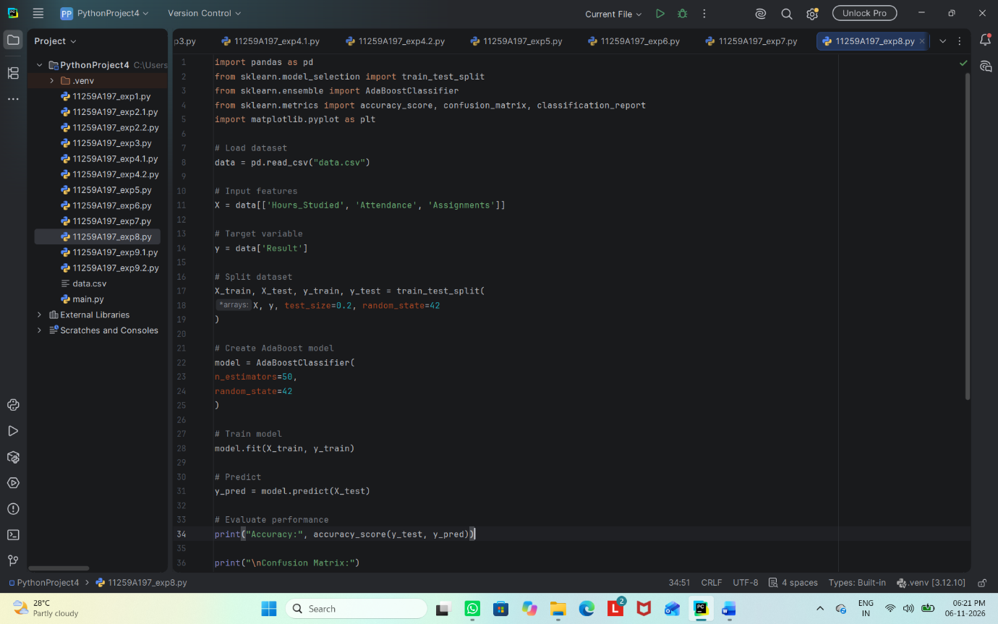

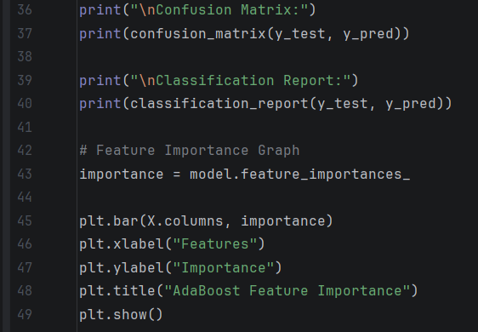

Output
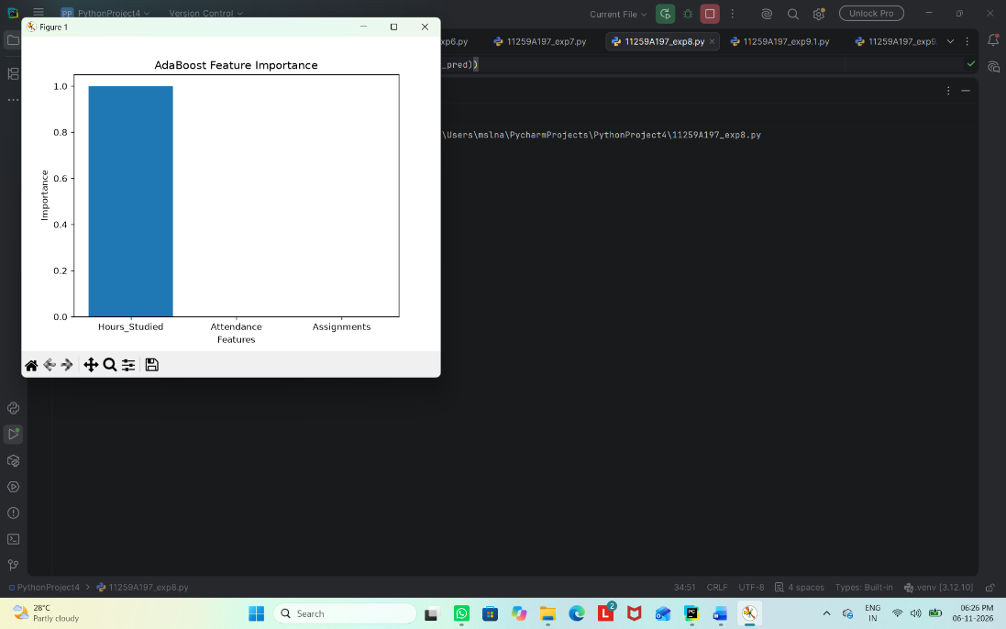

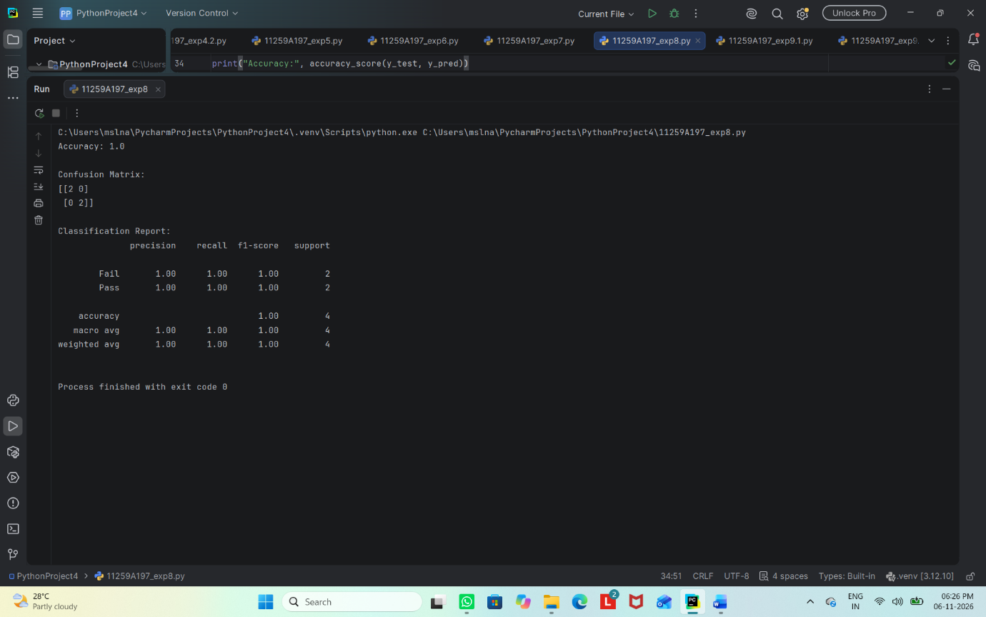

Result
Thus, AdaBoost was implemented to classify student results, and its performance and feature importance were examined.

EXPERIMENT 9.1
Basic Reinforcement Learning Using Q-Learning
Aim
To implement a basic Q-learning algorithm that learns a route to a goal state from a reward matrix.
Algorithm
1. Import NumPy and define a reward matrix representing permitted moves and rewards.
2. Initialize the Q-table with zeros.
3. Set the discount factor and number of training episodes.
4. For each episode, choose a starting state and repeatedly select a valid action.
5. Update the Q-value using immediate reward plus the discounted maximum future Q-value.
6. Print the learned Q-table.

Code
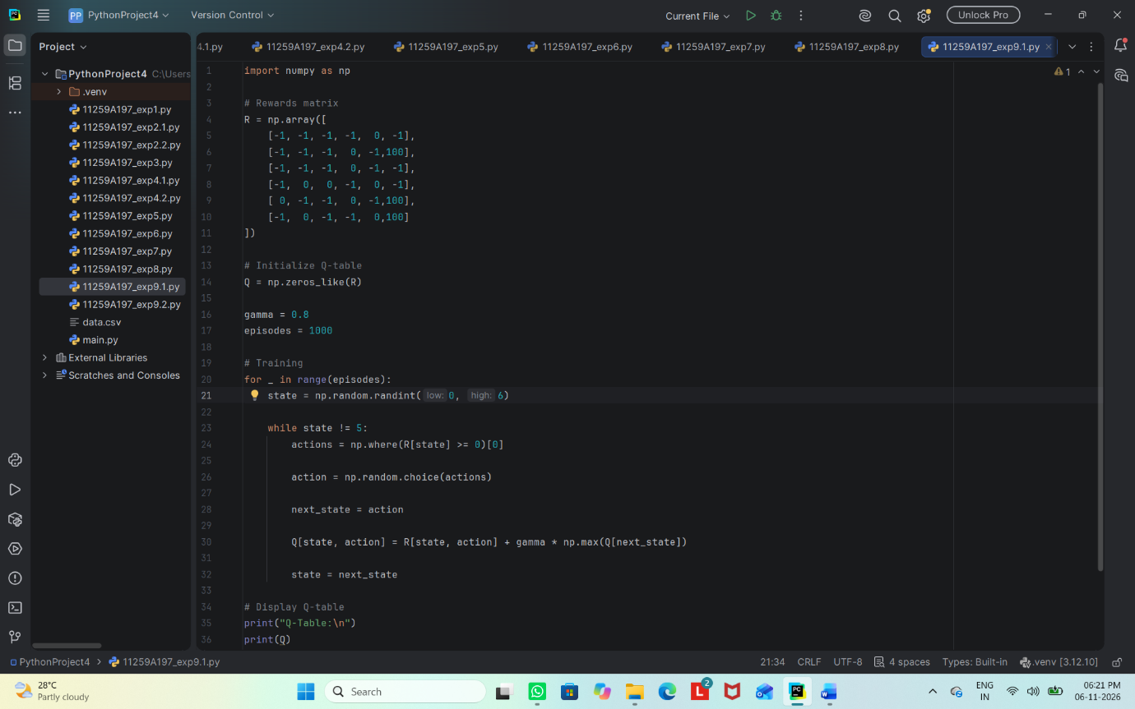
Output
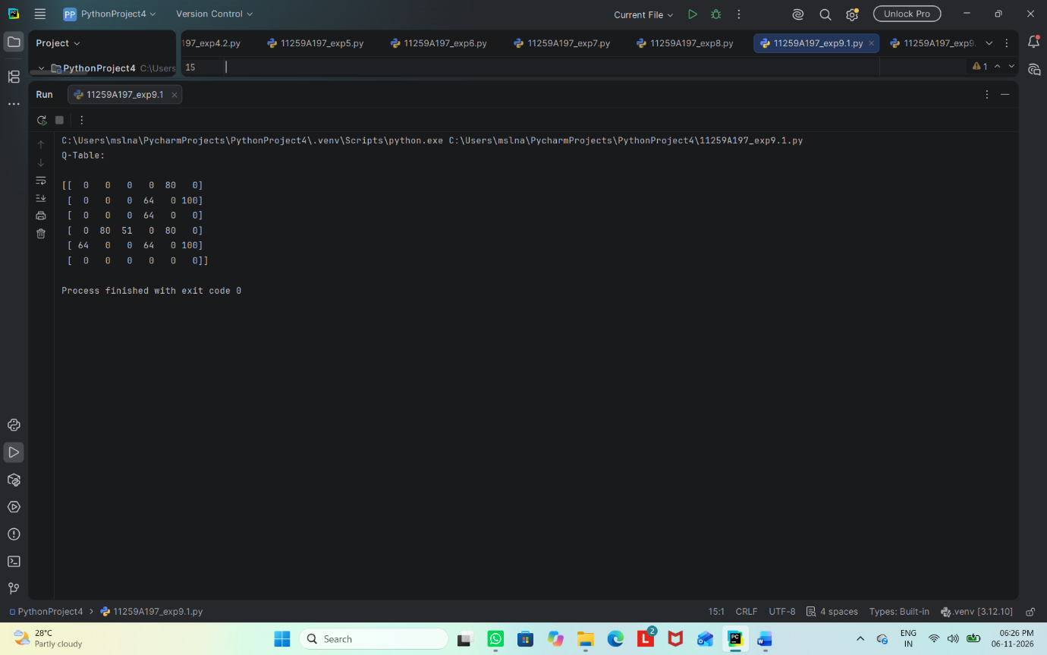

Result
Thus, the Q-learning model was implemented and the learned Q-table was displayed.

EXPERIMENT 9.2
Neural Network Classification
Aim
To build a basic feed-forward neural network to classify student results as Pass or Fail and measure its accuracy.
Algorithm
1. Import pandas, TensorFlow, train_test_split, StandardScaler, and accuracy_score.
2. Load data.csv and select the input features and Result target.
3. Convert Fail and Pass labels to numeric values 0 and 1.
4. Split the dataset into training and testing sets and standardize the features.
5. Build a neural network with two ReLU hidden layers and one sigmoid output neuron.
6. Compile the model, train it for 50 epochs, predict test labels, and calculate accuracy.

Code
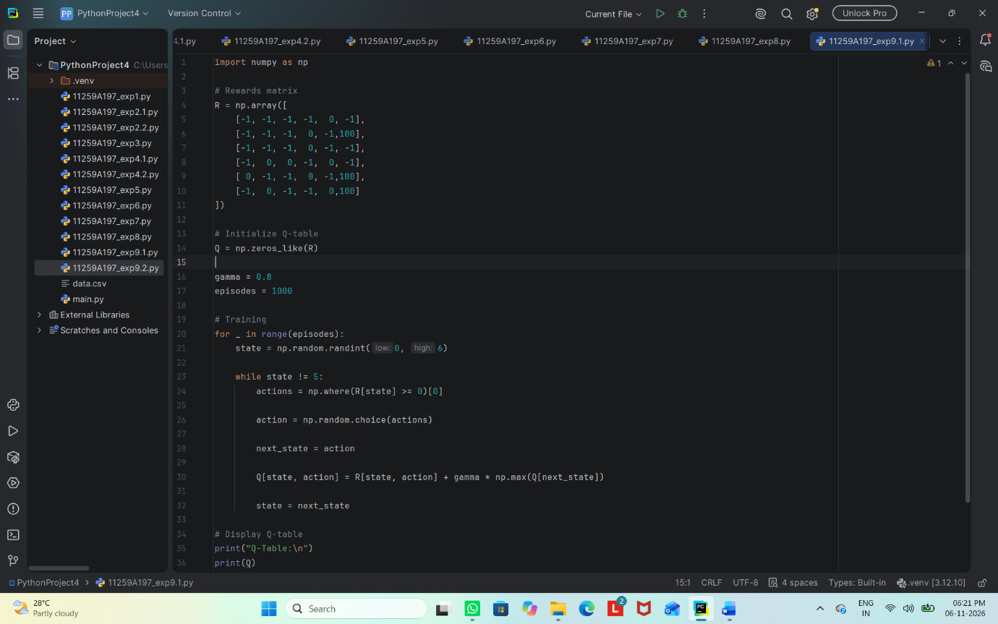

Output
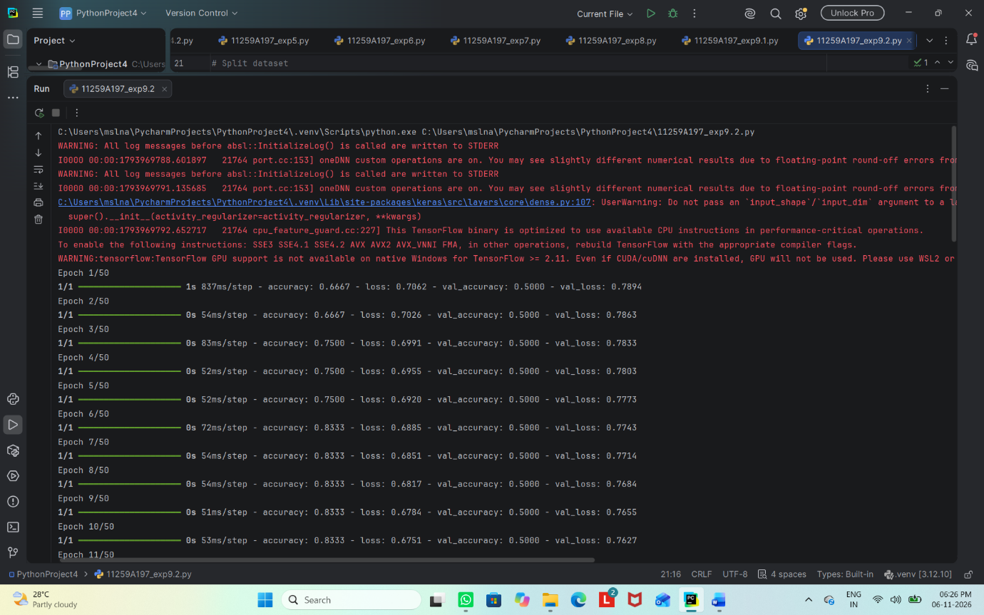
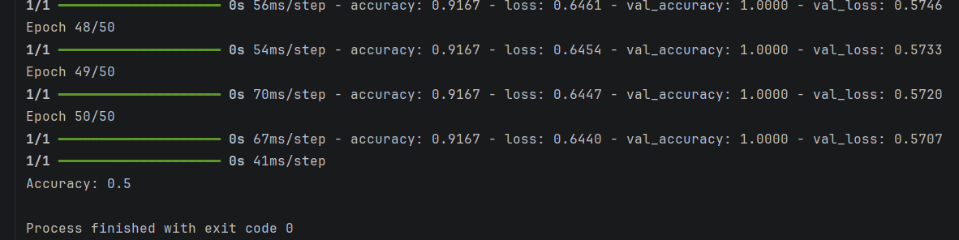
Result
Thus, a feed-forward neural network was designed and trained to classify student results, and its test accuracy was calculated.

